1, copy “MyNutrition.mdf” and “MyNutrition_log.ldf”

2, paste them into the folder like “C:\Program Files\Microsoft SQL Server\MSSQL10_50.SQLEXPRESS\MSSQL\DATA” (this path may be a little differ for your laptop)

3, start your sql server management, then click attach

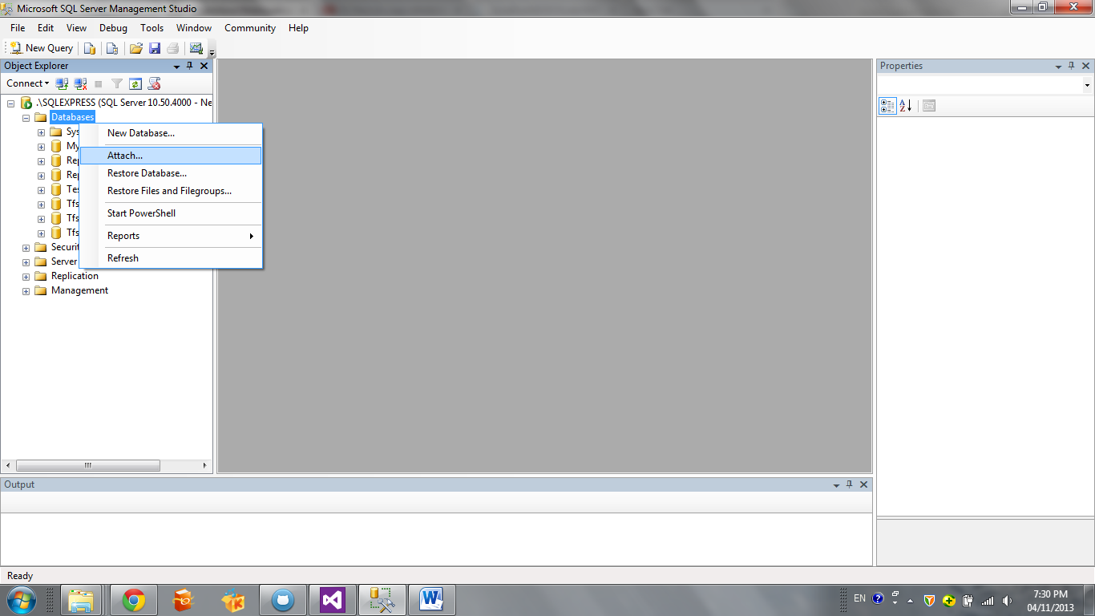

4, click add

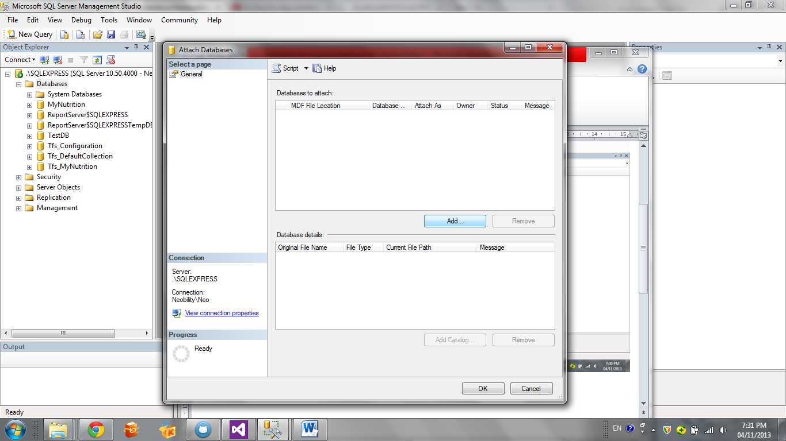

5, find the file “MyNutrition.mdf” you just pasted in step 2

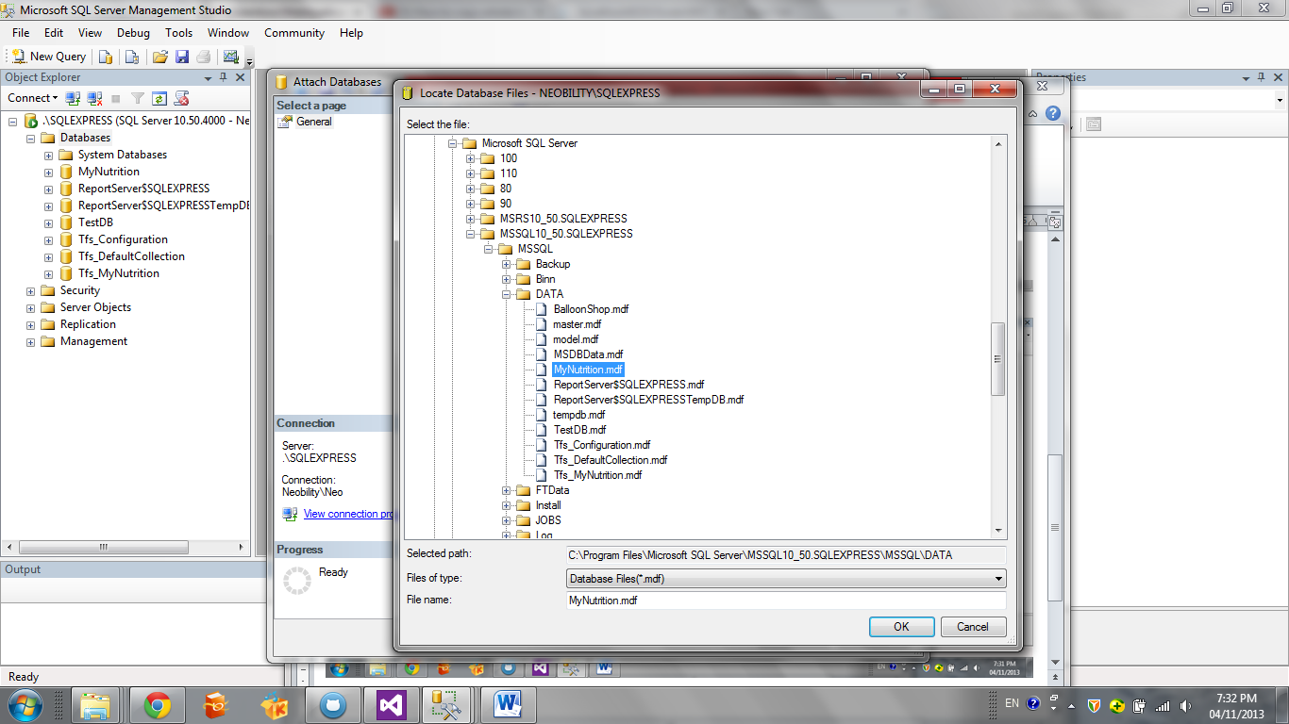

6,click ok, then refresh your database

7, congratulations, you have the copy of database in your local now!